Course Title : Big Data Analytics
Course Code : Z1AMC 702
Name: Saumya Patel Registration No: 2511042210022

Experiment 2: Hadoop Basic Commands
Title: Hadoop Basic Commands
- Objective
To understand and execute basic Hadoop HDFS commands for file and directory management.
- Procedure
  - Create a directory in HDFS.
  - Upload files to HDFS.
  - List files and directories.
  - View file contents.
  - Download files from HDFS.
  - Remove files and directories.
- Source Code
- Create directory
hdfs dfs -mkdir /demo
- Upload file
hdfs dfs -put sample.txt /demo
- List files
hdfs dfs -ls /demo
- View file content
hdfs dfs -cat /demo/sample.txt
- Download file
hdfs dfs -get /demo/sample.txt
- Delete file
hdfs dfs -rm /demo/sample.txt
- Delete directory
hdfs dfs -rmdir /demo
- Screen Shot
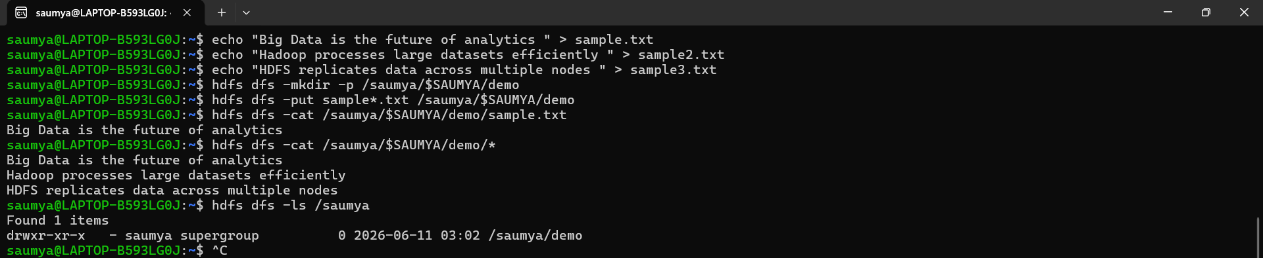
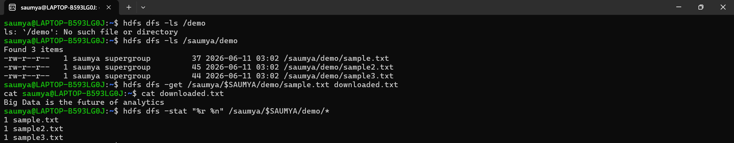

- Conclusion
Basic HDFS commands were executed successfully. Files and directories were created, uploaded, viewed, and deleted using Hadoop commands.

